Project I - Application Proposal
and Requirement Analysis
Course Name: Quality Assurance and Testing
Name: Devangbhai Pandit & Meet Ahalpara
Version: 1.0
Document ID: CST8513-P1-01
Date: 26th June 2026

Table of Contents
1. Introduction 3
2. Application Overview 4
3. Key Functionalities 5
4. Functional Requirements 6
4.1 Requirement Traceability 7
5. Non-Functional Requirements 8
6. Application Workflow 9
7. Preliminary Testing Types 10
8. Assumptions and Limitations 11
9. Conclusion 11
References 12

1. Introduction
SauceDemo is a public demonstration e-commerce web application developed by Sauce Labs for practicing software testing. Unlike a typical online shopping website, SauceDemo is intentionally designed to provide a stable environment where testers can repeatedly perform the same actions without affecting production data. It includes authentication, product browsing, sorting, shopping cart management, checkout, and order confirmation. These workflows closely resemble those of a real e-commerce application, making SauceDemo suitable for requirement analysis and future manual, automated, performance, and accessibility testing.
The objective of this project is to analyze the application's core business requirements, identify its primary functional and non-functional requirements, understand the complete user workflow, and identify the most appropriate testing techniques that will be applied in later phases of the course.

2. Application Overview
Objective: To analyze SauceDemo's primary features and behaviors to produce a requirement document that supports Phase II testing (manual, automated, performance, accessibility). SauceDemo was chosen because it provides a stable public demo environment with repeatable e-commerce workflows suitable for testing.
Attribute | Description
Application Name | SauceDemo
Application Type | Web-based E-commerce Demo
Developer | Sauce Labs
Purpose | Training and demonstration platform for software testing.
URL | https://www.saucedemo.com/
Primary Users | Students, QA Engineers, Software Testers, Automation Engineers
Main Objective | Simulate a complete online shopping experience suitable for testing.

After successful authentication, users can browse an inventory of products, sort items based on different criteria, manage a shopping cart, complete a multi-step checkout process, and receive an order confirmation. The application also provides different user accounts, including standard, locked-out, problem, performance-glitch, error, and visual users, allowing testers to evaluate different application behaviors.

3. Key Functionalities
User Authentication
Allows users to log in using valid usernames and passwords. Invalid credentials generate appropriate error messages.
Product Inventory
Displays available products including product name, description, image, and price.
Sorting
Users can sort products alphabetically or by price in ascending and descending order.
Shopping Cart
Products can be added, removed and reviewed before checkout.
Checkout
Collects customer information through validated input fields before completing an order.
Order Confirmation
Displays purchase summary and confirmation after successful checkout.
Logout
Terminates the current session securely and returns the user to the login page.
In-scope
Authentication, inventory, cart, checkout, order confirmation, logout.
Out-of-scope
Backend code, real payment processing, inventory persistence, admin functions.

4. Functional Requirements

ID | Requirement | Description | Related Feature
FR-01 | Login | The system shall authenticate users with valid credentials and redirect them to the inventory page. | Authentication
FR-02 | Login Validation | The system shall display clear error messages for invalid credentials or locked-out accounts. | Authentication
FR-03 | Inventory Display | The system shall display all available products after successful login. | Product Inventory
FR-04 | Sorting | The system shall allow users to sort products by name and price in ascending and descending order. | Sorting
FR-05 | Product Details | The system shall display each product’s image, name, description, and price. | Product Inventory
FR-06 | Add to Cart | The system shall allow users to add one or more products to the shopping cart. | Shopping Cart
FR-07 | Remove from Cart | The system shall allow users to remove products from the shopping cart and update the cart count immediately. | Shopping Cart
FR-08 | Cart Review | The system shall display selected products in the cart before checkout. | Shopping Cart
FR-09 | Checkout Information | The system shall require First Name, Last Name, and Postal Code during checkout. | Checkout
FR-10 | Input Validation | The system shall prevent checkout from continuing if required fields are missing. | Checkout
FR-11 | Order Overview | The system shall display the selected items, tax, and total amount before final purchase. | Checkout
FR-12 | Finish Order | The system shall complete the purchase and show an order confirmation page. | Order Confirmation
FR-13 | Cancel Checkout | The system shall allow users to cancel checkout and return to the inventory page. | Checkout
FR-14 | Logout | The system shall securely end the user session and return to the login page. | Logout

4.1 Requirement Traceability

FR ID | Workflow Stage | Planned Test Types
FR-01 | Login | Functional, UI, Validation
FR-02 | Login Validation | Functional, Validation
FR-03 | Inventory Display | Functional, UI
FR-04 | Sorting | Functional, UI, Regression
FR-05 | Product Details | Functional, UI
FR-06 | Shopping Cart | Functional, Smoke, Regression
FR-07 | Shopping Cart | Functional, Regression
FR-08 | Cart Review | Functional, UI
FR-09 | Checkout Information | Functional, Validation
FR-10 | Input Validation | Functional, Validation
FR-11 | Order Overview | Functional, UI
FR-12 | Order Confirmation | Functional, Regression
FR-13 | Cancel Checkout | Functional, Regression
FR-14 | Logout | Functional, Security

5. Non-Functional Requirements
Besides implementing the required business functions, SauceDemo should satisfy several quality attributes that improve usability and reliability.
- Performance: The application shall respond within an acceptable time under normal operating conditions to provide smooth user experience.
- Usability: Navigation shall be simple and consistent so users can complete checkout without confusion.
- Reliability: Login, cart, and checkout flows shall work consistently during repeated test runs.
- Security: Passwords shall be masked, and unauthorized users shall not access protected pages.
- Compatibility: The system shall be compatible with and fully functional on current versions of Chrome, Firefox, Edge, and Safari.
- Accessibility: All interactive elements shall be usable with a keyboard and have clear labels.

6. Application Workflow
The SauceDemo workflow begins when the user opens the website and reaches the login page. The user enters a username and password, and the system checks whether the credentials are valid. If the login details are incorrect, the system displays an error message and keeps the user on the login page. If the login is successful, the user is redirected to the inventory page.
On the inventory page, the user can browse products, sort them by name or price, and add selected items to the cart. The system updates the cart count whenever an item is added or removed. After reviewing the cart, the user can either continue shopping or proceed to checkout.
During checkout, the user must enter required information such as first name, last name, and postal code. If any field is missing, the system displays a validation error and does not continue to the next step. If all required information is entered correctly, the system shows the order overview, including selected items, price, tax, and total amount.
The user can then either cancel the checkout or finish the purchase. If the user cancels, the system returns them to the inventory page. If the user completes the purchase, the system displays an order confirmation message. After that, the user can log out to securely end the session and return to the login page.
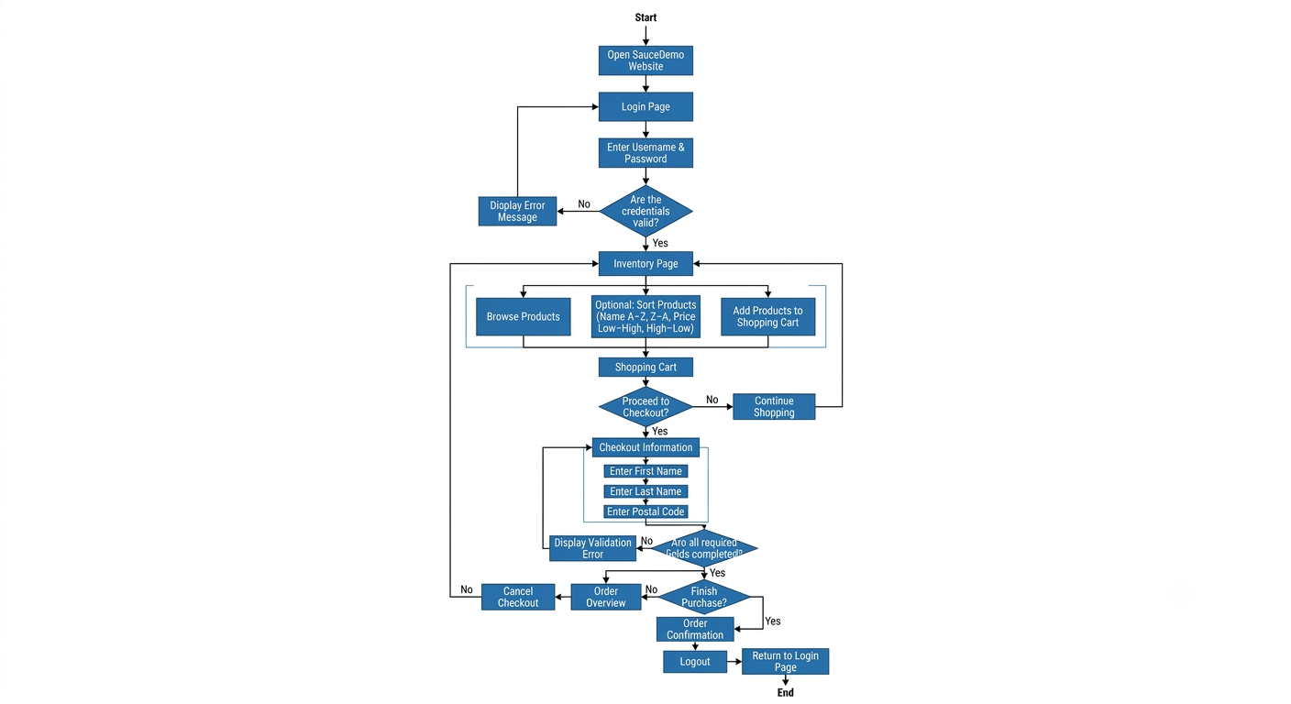
Figure 1: High-Level User Workflow for SauceDemo.

7. Preliminary Testing Types
Testing Type | Analysis
Functional Testing | Verify that every business requirement such as login, inventory display, cart management and checkout performs according to specifications.
UI Testing | Ensure buttons, labels, menus, forms, images and navigation remain consistent and user-friendly across pages.
Validation Testing | Verify mandatory fields, invalid credentials, empty inputs and incorrect data produce appropriate validation messages.
Smoke Testing | Confirm that the application's critical workflows (login, add to cart and checkout) function correctly after deployment.
Regression Testing | Ensure previously working features continue functioning after application updates.
Automation Testing | SauceDemo is highly suitable for Selenium, Cypress and Robot Framework because of its stable interface and repeatable workflows.
Performance Testing | Evaluate page response times, application stability, and behaviour under multiple-user workloads using tools such as JMeter.
Accessibility Testing | Check keyboard navigation, focus order, readable labels and overall compliance with accessibility guidelines.
Negative Testing | Verify that the system handles invalid, unexpected, or malicious input (e.g., leaving mandatory checkout fields blank) gracefully without system crashes or security vulnerabilities.

8. Assumptions and Limitations
- Assumptions
- The application remains publicly accessible during testing.
- Users have access to valid demo credentials.
- Internet connectivity is available.
- Limitations
- The demo environment is shared; therefore, data may change between executions.
- No real payment gateway or inventory management system exists.
- Backend source code is unavailable for white-box testing.
- The scope of testing is limited to the frontend UI and functional workflows; backend API testing and database validation are excluded as access is restricted.

9. Conclusion
SauceDemo meets all the project selection requirements by providing a realistic and interactive e-commerce workflow that supports repeated testing. The application contains sufficient functionality for requirement analysis while remaining simple enough to understand. Its authentication process, inventory management, shopping cart and checkout modules provide a strong basis for designing detailed test cases, automation scripts, performance tests and accessibility evaluations in the next phases of the project. The functional and non-functional requirements identified in this document will serve as the foundation for developing the testing strategy and test cases in Phase II of the project.

References

[1] | "WCAG 2 Overview," w3, [Online]. Available: https://www.w3.org/WAI/standards-guidelines/wcag/.
[2] | "User's Manual," APACHE, [Online]. Available: https://jmeter.apache.org/usermanual/.
[3] | "Why Cypress?," Cypress Docs, [Online]. Available: https://docs.cypress.io/app/get-started/why-cypress.
[4] | "The Selenium Browser Automation Project," Selenium, [Online]. Available: https://www.selenium.dev/documentation/.
[5] | "Sauce Labs Documentation," Sauce Labs, [Online]. Available: https://docs.saucelabs.com/.
[6] | "Sauce Demo," Swag Labs, [Online]. Available: https://www.saucedemo.com/.

